**GENERAL INTEGRATED SCIENCE – UNIT 4**

**TASK 6 – SIMILAR INGREDIENTS EXTENDED RESPONSE**

**NAME: _________________________________ WEIGHTING: 15%**

**DUE DATE: _________________________________ MARK: ______ / 69 = ______ %**

**Question: *Do the properties of a substance make it what it is?***

**Objectives**

* the use of substances is determined by the chemical and/or physical properties of the constituent chemicals
* rearrangement of reactant components occurs during chemical reactions to form new substances

**Task 1 – Research *(5 marks)***

You are to research the following questions in reference to ***BOTH*** eggs and plain flour in the baking process.

1. State their physical properties
2. State their chemical properties
3. Describe the uses of both eggs and plain flour in baking
4. What are the similarities between eggs and plain flour in the context of baking?
5. What are the differences between eggs and plain flour in the context of baking?
6. Both eggs and plain flour can be replaced in recipes with alternatives.
   1. Explain how egg can be replaced with the following. ***Include what is it and how it works.***
      1. Egg Replacer
      2. Chia Seeds
      3. Apple Sauce
   2. Explain how plain flour can be replaced with the following. ***Include what is it and how it works.***
      1. Gluten-free Flour
      2. Cornflour
      3. Almond meal
7. Describe one physical and chemical change that occurs during baking because of egg.
8. Describe one physical and chemical change that occurs during baking because of flour.
9. Discuss the difference between a **food intolerance** and a **food allergy** – i.e. the effect on the

human body

1. Find a recipe that uses both eggs and plain flour. State the function of eggs and plain flour within

the context of the recipe you have chosen.

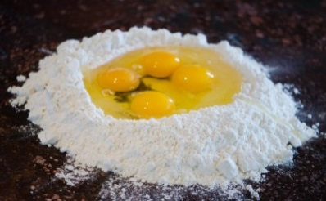**Task – Extended Response *(64 marks)***In class you will respond to a series of questions based on your research

on similar ingredients in the cooking process.

**In-Class Extended Response *(5 mins reading and 55 mins assessment)***

Use your research notes to answer all questions below.

1. **Outline** two similarities between the use of egg and plain flour within baking. (2 marks)

________________________________________________________________________________________________________________________________________________________________________________________________________________________________________________________________________________________________________________________________________

1. **Describe** the differences between the uses of egg and plain flour within baking. (6 marks)

____________________________________________________________________________________________________________________________________________________________________________________________________________________________________________________________________________________________________________________________________________________________________________________________________________________________________________________________________________________________________________

1. Outline the **physical properties** of both egg and flour using the five senses. (10 marks)

|  |  |
| --- | --- |
| **SENSES** | **EGG EXAMPLE** |
|  |  |
|  |  |
|  |  |
|  |  |
|  |  |
| **SENSES** | **FLOUR EXAMPLE** |
|  |  |
|  |  |
|  |  |
|  |  |
|  |  |

1. State three chemical properties of an egg and outline/define what they are. (6 marks)

________________________________________________________________________________________________________________________________________________________________________________________________________________________________________________________________________________________________________________________________________

1. Explain what the following replacements **are** and **how** they work…….
2. Chia Seeds (3 marks)

________________________________________________________________________________________________________________________________________________________________________________________________________________________________________________________________________________________________________________________

1. Apple Sauce (3 marks)

________________________________________________________________________________________________________________________________________________________________________________________________________________________________________________________________________________________________________________________

1. State and describe three chemical properties of Plain Flour (3 marks)

________________________________________________________________________________________________________________________________________________________________________________________________________________________________________________________________________________________________________________________________________

1. Explain what the following replacements **are** and **how** they work…….
2. Cornflour (3 marks)

________________________________________________________________________________________________________________________________________________________________________________________________________________________________________________________________________________________________________________________

1. Gluten Free Flour (3 marks)

________________________________________________________________________________________________________________________________________________________________________________________________________________________________________________________________________________________________________________________

**CUSTARD TART**

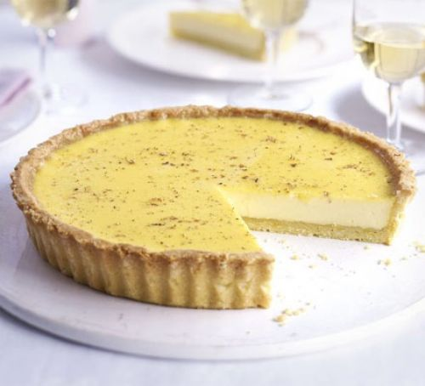**For the pastry For the custard**

140g butter 250ml double cream

250g plain flour 250ml milk

zest 1 lemon 1 vanilla pod, split

100g golden caster sugar 1 strip lemon zest

1 egg Pinch of nutmeg

1 tbsp whole milk 8 egg yolks

**Method**

To make the pastry, rub the butter into the flour with the lemon zest and a pinch of salt until it resembles breadcrumbs. Add the sugar, egg and milk and bring together to form a dough. This can be made 2 days in advance.

On a lightly floured surface, roll the pastry out and use it to line a 20cm tart tin, leave 2cm of pastry hanging over the edge. Chill for 30 mins.

**Bring the cream, milk, vanilla pod, lemon zest and a small grating of nutmeg to the boil. Beat the egg yolks with the sugar until pale, then pour the hot milk and cream over, beating as you go. Strain custard into a jug, allow to settle for a few mins, then skim off any froth.**

Carefully pour the custard into the tart case, grate some more nutmeg over the top and bake for 40 mins or until just set with the very slightest wobble in the middle. Remove from the oven, trim the pastry edges off (away from the filling), then leave to cool completely before serving in slices with a grating more of nutmeg, if you like.

1. State whether creating a custard tart is a chemical or physical change. Justify your answer. (2 marks)

________________________________________________________________________________________________________________________________________________________________________________________________________________________________________________________________________________________________________________________________________

1. Outline several chemical changes that have occurred to the egg in the Custard Tart recipe during the baking process? (3 marks)

________________________________________________________________________________________________________________________________________________________________________________________________________________________________________________________________________________________________________________________________________

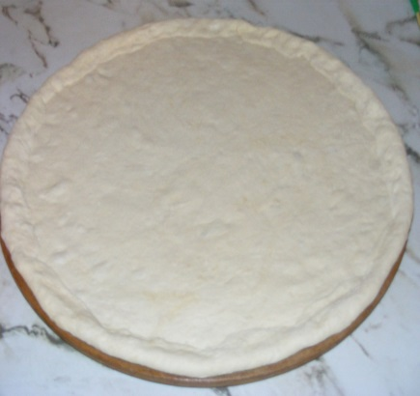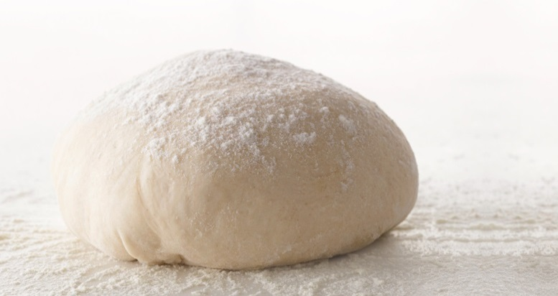**Pizza Dough**

185ml warm water

7g dry yeast

225g plain flour

1 tsp salt

¼ cup olive oil

**Method**

1. Combine water AND yeast. Set aside till foamy.
2. Combine flour and salt in large bowl, make well into centre. Add yeast mixture.
3. Use your hands to bring the dough together. Knead until smooth and ‘elastic’.
4. Wipe bowl with olive oil, (so dough does not stick)
5. Place dough in bowl, cover with Gladwrap, set aside in warm place to rise or dough doubles in size.
6. Separate dough into several pieces and roll out, place on your pizza tray and top.
7. Two major reactions occur during the pizza dough making process that makes it useful to its purpose. Explain the two reactions, using a word equation for each reaction. (3 marks)

________________________________________________________________________________________________________________________________________________________________________________________________________________________________________________________________________________________________________________________________________

1. The yeast's function in bread? (1 mark)

____________________________________________________________________________________________________________________________________________________________________

1. Define the term **Leavening**, in reference to making dough/bread products. (1 mark)

____________________________________________________________________________________________________________________________________________________________________

1. Why do you knead bread dough? (2 marks)  
   ________________________________________________________________________________________________________________________________________________________________________________________________________________________________________________________________________________________________________________________________________
2. What causes the ‘elastic’ nature in bread dough to form? (2 marks)

______________________________________________________________________________________________________________________________________________________________________________________________________________________________________________________

1. Macromolecules can be found in all food products. They include carbohydrates, proteins and fats. What is gluten? (1 mark)

____________________________________________________________________________________________________________________________________________________________________

1. Name and briefly explain the functional property that occurs to the colour of dough when it is cooking. (2 marks)

________________________________________________________________________________________________________________________________________________________________________________________________________________________________________________________________________________________________________________________________________

1. Outline and discuss the differences between Food Intolerance and Food Allergy. Include a symptom for each. (7 marks)

____________________________________________________________________________________________________________________________________________________________________________________________________________________________________________________________________________________________________________________________________________________________________________________________________________________________________________________________________________________________________________________________________________________________________________________________________________________________________________________________________________________________________________________________________________________________________________________________________________________________________________________________________________________________________________________________________________________________________________________________________________________________________________________________________________________________________________________________________________________________________________________________________________________________________________________________________________________________________________________________________________________________________________________________________________________________________________________________________________________________________________________________________  
__________________________________________________________________________________